LORD FAIRFAX COMMUNITY COLLEGE

CLASSROOM & OFFICE HOURS
Fall 2021

Instructor: Lisa Kara Phone: 540-868-7117
Office: Middletown, Fairfax Hall Room 301F e-mail: lkara@lfcc.edu

Lisa Kara’s Zoom Meeting Room:
Lisa Kara’s Contact Info:

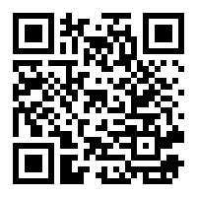
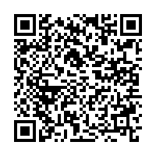

HOURS | MONDAY | TUESDAY | WEDNESDAY | THURSDAY | FRIDAY
8-8:30 AM | ADJ 100  Survey of CJ  Fairfax Hall 406  8:00-9:20 |  | ADJ 100  Survey of CJ  Fairfax Hall 406  8:00-9:20
8:30-9 AM
9-9:30 AM
9:30-10 AM | ADJ 107  Survey of Criminology  Fairfax Hall 406  9:30-10:50 |  | ADJ 107  Survey of Criminology  Fairfax Hall 406  9:30-10:50
10-10:30 AM
10:30-11 AM
11-11:30 AM | Office Hours  Fairfax Hall  Room 301F  In-person or  by Zoom, phone, or chat  11:00-2:30 |  | Office Hours  Fairfax Hall  Room 301F  In-person or by Zoom, phone, or chat  11:00-2:30
11:30-12 PM
12-12:30 PM
12:30-1 PM
1-1:30 PM
1:30-2 PM
2-2:30 PM
2:30-3 PM |  |  |  |  | Online Classes  ADJ 100.100V Survey of Criminal Justice  ADJ 105.100V The Juvenile Justice System  ADJ 164.100V Case Studies in Murder/Violent Crime
3-4:00 PM
4-5:00 PM | Office Hours  Online  Zoom, Phone, or Chat  4-7:00
5-6:00 PM
6-7:00 PM

